
The Interactive Process
And Service Providers

Effective Accommodation Practices (EAP) Series

JAN’S EAP SERIES

The Interactive Process and Service Providers

The Americans with Disabilities Act (ADA) requires covered employers to provide effective, reasonable accommodations for individuals with disabilities. To help determine effective accommodations, the Equal Employment Opportunity Commission (EEOC), recommends that employers use an “interactive process,” which simply means that employers and employees with disabilities who request accommodations work together to come up with effective accommodations.

Service providers may play an important role in the interactive process. For example, they may be called upon to provide information about accommodation solutions and/or assistive technologies that will optimize job performance or they may be asked to provide documentation in support of an individual’s accommodation request.

For a better understanding of when service providers may be included in the interactive process, the following is an example of what the interactive process might look like.

Step 1: Making an Accommodation Request

The interactive process starts with an accommodation request by an individual with a disability. An individual can request an accommodation at any time during the application process or while employed. In general, individuals should request accommodations when they become aware that there is a workplace barrier that is preventing them, due to a disability, from competing for a job, performing a job, or gaining equal access to a benefit of employment. The EEOC also has indicated that a family member, friend, service provider, or other representative may request a reasonable accommodation on behalf of an individual with a disability.

So what constitutes an accommodation request? According to the EEOC, an individual may use "plain English" and need not mention the ADA or use the phrase "reasonable accommodation" when requesting an accommodation. Therefore, any time an individual indicates that he/she is having a problem and the problem is related to a medical condition, the employer should consider whether the individual is making a request for accommodation under the ADA.

Service providers may be working with individuals with disabilities through job placement, vocational rehabilitation, or any other career development program. In these instances, a service provider may make an accommodation request on behalf of a client or may assist a client in making the request.

The EEOC (Reasonable Accommodation and Undue Hardship (EEOC Guidance) at http://www.eeoc.gov/policy/docs/accommodation.html) provides the following example:

An employee has been out of work for six months with a workers' compensation injury. The employee's doctor sends the employer a letter, stating that the employee is released to return to work, but with certain work restrictions. (Alternatively, the letter may state that the employee is released to return to a light duty position.) The letter constitutes a request for reasonable accommodation.

Tips for Service Providers:

- Make sure clients are aware of their rights under the ADA. Title I of the ADA requires an employer, with 15 or more employees, to provide reasonable accommodation to qualified individuals with disabilities who are employees or applicants for employment, unless doing so would cause undue hardship.

- Document the request. While an accommodation request does not have to be in writing, the EEOC suggests that individuals with disabilities might find it useful to document accommodation requests in the event there is a dispute about whether or when they requested accommodation.

- Be clear and specific. Service providers or the individual can describe specific needs and offer suggestions for accommodation ideas. Although not required, it may be helpful to specify that the individual is requesting a “reasonable accommodation” under the “ADA.”

Step 2: Providing Information

Once an accommodation request has been received, the employer is allowed to gather whatever information is necessary to process the request. Necessary information may include documentation of the disability and need for accommodation. In some cases, the disability and need for accommodation are obvious and no additional information is needed. For example, if an employee who recently started using a wheelchair indicates that he needs a ramp to get into the workplace, the disability and need for accommodation are obvious.

In other cases, employers may need additional information. For example, if an employee with a non-visible disability indicates she is having trouble completing her work tasks because of her disability, the employer does not have enough information to provide effective accommodations. The employer needs to know what limitations are interfering with job performance and what specific work tasks are an issue.

Service providers can play an important role in providing information regarding an individual’s disability and functional limitations. For example, a vocational rehabilitation counselor may have results from an assessment or evaluation that explains what an individual specifically needs to perform job tasks.

Tips for Service Providers:

- Describe the limitation and problem. To find effective accommodations, employers need to know what limitation is causing the problem. Service providers may be able to supply this information.

- Get information from the individual when possible. Individuals with disabilities are familiar with their limitations and often know what accommodations will work best for them.

- Use ADA language. When providing documentation, service providers may want to use the ADA’s specific language so the information will be helpful for employers.

Step 3: Exploring Accommodation Options

Once the employer has identified the individual’s limitation that is causing a problem and has identified what that problem is, then the employer is ready to explore accommodation options. At this step, employers should be open to new ideas and new ways of doing things. This is the time to brainstorm and consider what might work.

When exploring accommodation options a service provider, such as an ergonomist, may do a job analysis, which could include an ergonomic evaluation to assess the work environment and define any potential problems. Some service providers may be able to provide feedback to determine what assistive technology options may be deemed appropriate as an accommodation.

Tips for Service Providers:

- Keep an open mind. Accommodations are about doing things differently to help overcome disability-related limitations, so keep an open mind when exploring accommodation options.

- Invite the individual to suggest accommodations. The individual who requested the accommodation may have some good accommodation ideas, but may be hesitant to bring them up without being asked to do so.

- Consult with other service providers. In many instances, it may be necessary for a team of service providers to work together to develop an effective accommodation strategy.

- Use JAN when needed. JAN is a free, national resource for individuals, employers, and service providers who are seeking help coming up with accommodation ideas.

Step 4: Choosing an Accommodation

Once accommodation options have been explored, the employer gets to choose what accommodation to implement. If there is more than one option, the employer should consider the preference of the employee, but is not required to do so; the employer gets to choose among effective options and can choose, for example, the lowest cost accommodation.

When an individual feels strongly about a certain accommodation, service providers may be able to help the individual develop ideas to try to convince the employer to choose the preferred accommodation. These ideas should focus on how the accommodation will benefit both the individual and the employer by overcoming limitations and making the individual more productive.

If the employer still is not convinced to choose the preferred accommodation, service providers can suggest that the employer try out the accommodation. If it does not work, the employer is free to choose a different accommodation. One thing employers might want to do when testing accommodations is to make a written agreement with the individual that the accommodation is being tested, how long the test will be, and what will happen if the accommodation does not work. That way, no one is surprised when the accommodation is revisited down the road.

Tips for Service Providers:

- Explain decision making process. Let the client know that employers have the right to choose among effective accommodation options in case the employer does not choose the client’s preferred accommodation.

- Justify preferences. If the client feels strongly about the preferred accommodation, help him/her develop a list of reasons why the preferred accommodation is the best accommodation.

Step 5: Implementing the Accommodation

Once an accommodation has been chosen, the employer must implement the accommodation. Service providers can be an integral part of this step in the interactive process. For example, service providers can help train the individual how to use an assistive device or software. When equipment is involved, service providers can help properly install the equipment and train the individual how to use it. In some cases, an individual may need continued support while adjusting to an accommodation and a service provider, such as a job coach, can assist during this stage. Service providers also can provide feedback on the effectiveness of the accommodation once it is in place.

Tips for Service Providers:

- Offer assistance during the implementation of the accommodation. Service providers can provide assistance setting up and training on equipment and devices and can provide support to the individual, who may need help adjusting to the accommodation.

- Make sure to involve the individual throughout the implementation of the accommodation. Communicate with the client while implementing the accommodation to help ensure success.

Step 6: Monitoring the Accommodation

An important but often forgotten part of the interactive process is monitoring accommodations after they are in place. In some cases, an accommodation stops being effective for various reasons such as: the individual’s limitations change, workplace equipment changes, the job changes, the workplace itself changes, or the accommodation becomes an undue hardship for the employer.

Because changes occur, employers may need to revisit accommodations. If an accommodation is not working as anticipated, service providers may be able to provide additional assistance or suggestions for alternatives. Service providers also can assist when equipment or technology needs routine maintenance or updating. For example, if a software company releases a new version of its software, an assistive technology specialist can help the individual learn how to use the new version.

In situations where reassignment is necessary, service providers can provide information to the employer about any accommodation suggestions or recommendations for a new position.

Tips for Service Providers:

- Check on effectiveness. As things change in the workplace, accommodations may need to also change. Service providers may be able to routinely check on the effectiveness of accommodations.

- Leave the individual in good hands. Make sure the individual can troubleshoot basic problems with equipment or devices and knows who to contact when products are not functioning properly.

- Encourage ongoing communication. For any workplace issue, ongoing communication is the key to success. The same is true for accommodations – individuals should be encouraged to communicate any issues they have with their accommodations.

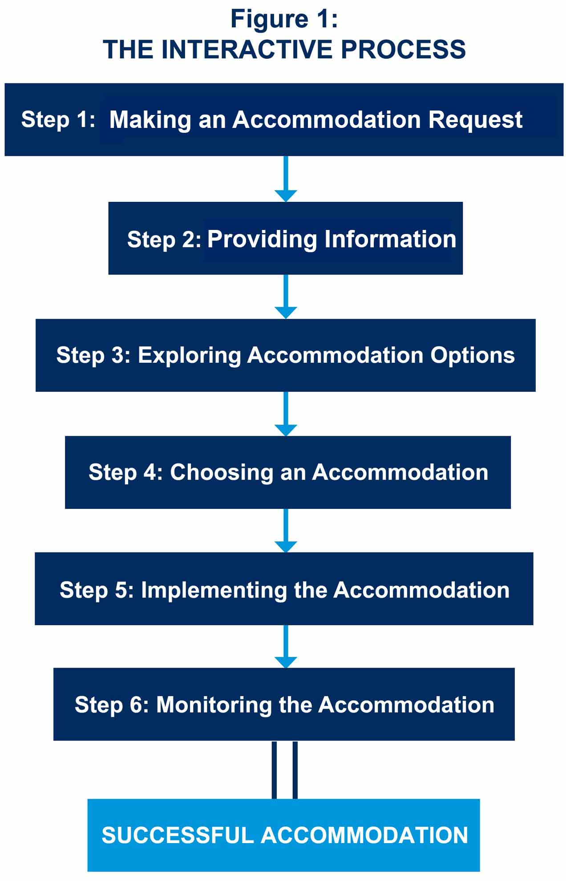

Updated 05/31/2018.

This document was developed by the Job Accommodation Network, funded by a contract from the U.S. Department of Labor, Office of Disability Employment Policy (#1605DC-17-C-0038). The opinions expressed herein do not necessarily reflect the position or policy of the U.S. Department of Labor. Nor does mention of tradenames, commercial products, or organizations imply endorsement by the U.S. Department of Labor.

